Internal Analysis: McKinsey 7S Model
Why we used the McKinsey 7S model
The brief asks for one framework for the internal analysis. We chose the McKinsey 7S model, which looks at seven connected parts of an organisation: strategy, structure and systems (the "hard" parts) and shared values, style, staff and skills (the "soft" parts) (Waterman, Peters and Phillips, 1980). We chose it for four reasons.
First, it is built for internal analysis. It looks only inside the organisation, while our PEST analysis covers the external environment. Second, it covers the whole organisation, both its hard and soft sides, so we can analyse IIT in general rather than just its sustainability work. Third, its main idea is that the seven parts must support each other, and a change in one only works if the others back it up (Waterman, Peters and Phillips, 1980). This fits IIT well: it has the ambition and the people, but its structure and systems do not yet support where it wants to go. A SWOT analysis would list these points but would not show how they connect. Fourth, 7S is widely used to check whether an organisation is ready for a major change, and IIT is about to move campus and launch a large sustainability programme.
In Table 1 we compare where IIT is now with where it says it wants to be: "to stand among the eminent higher learning institutions in the region" (IIT, n.d.a) and Sri Lanka's leading sustainable technology campus by 2030 (IIT, 2026a). IIT does not publish an organisation chart or internal data, so some points are assumptions and are marked as such.
Table 1: McKinsey 7S analysis of IIT: where it is now, where it wants to be, and what helps or holds it back
7S element | Current status (IIT in general) | Where IIT wants to be | Enablers (+) and barriers (–)
Strategy  Hard S | Offers British degrees in IT and Business in Sri Lanka at a fraction of the cost of studying abroad, focused on employability, for over 35 years (IIT, n.d.a). Growing through twelve partner universities, its own UGC-approved BBA (IIT, 2026c), a Galle centre, short courses (PDU) and schools outreach through DDL (IIT, n.d.e). | One of the leading higher education institutions in the region, known for teaching and research, awarding more of its own degrees, and Sri Lanka's leading sustainable technology campus by 2030 (IIT, n.d.a; IIT, 2026a). | + A 35-year reputation and a clear, proven market position.  + Its own BBA shows a first step towards awarding its own degrees.  + The 2030 sustainability goal gives IIT a distinctive angle against competitors.  – Still depends mostly on partners' degrees, fees and rules.  – Growing in many directions at once spreads management attention thinly.  – The sustainability goals have no baseline and no costed plan yet.
Structure  Hard S | Private BOI-registered company owned within the Informatics Group (IIT, n.d.d). Central senior management; academic work split into Computing, the Business School, postgraduate and Foundation; many units added over time (SRU, Alumni, PDU, DDL, LeapGen); campuses in Colombo and Galle, with Ratmalana being built. See Figure 1. | A structure that can run several campuses and handle priorities that cut across every department, such as research, quality and sustainability. | + Fast, top-down decisions.  + A new Sustainability Office and Digital Transformation Lead (IIT, 2026a).  + The move to Ratmalana is a chance to redesign how the campus is run.  – A functional structure with a strong top creates silos (Mintzberg, 1979; Johnson et al., 2020).  – Units were added one by one, with no one coordinating them.  – The Sustainability Office has no authority over schools, IT or facilities.
Systems  Hard S | ISO 9001:2015 certified, UGC recognised, TVEC registered and BCS accredited (IIT, n.d.a). Uses an LMS and a digital library. Works within partner universities' quality systems. Little data on energy, water, waste or IT equipment, and no public reporting (IIT, 2026a). | Joined-up, data-driven management, with clear performance measures for both academic work and campus operations, an annual GRI-aligned report and a ranking entry by 2028 (IIT, 2026a). | + A documented, audited quality system to build on.  + Strong in-house IT ability to build new tools.  – Several partner quality systems add staff workload.  – No joined-up operational data and no baseline.  – Nothing is reported publicly yet.
Shared values  Soft S | Vision of regional excellence in teaching and research. Eleven listed values, including innovation, excellence, practical application and community engagement (IIT, n.d.a). | A clear identity that staff and students share, joining excellence and innovation with sustainability. | + The values are lived out through placements, competitions and the SDGP module (IIT, n.d.b).  + "Community engagement" already mentions sustainable development.  – Eleven values is too many to guide hard choices.  – Sustainability is not yet a core value.
Style  Soft S | Entrepreneurial and founder-led. First to market with many programmes, runs the LeapGen accelerator and celebrates competition wins (IIT, n.d.a; IIT, n.d.c). Big decisions come from the top; day-to-day initiatives come from clubs and lecturers (IIT, 2026a). | Leadership that keeps its entrepreneurial energy but adds clear targets and accountability across the whole organisation. | + Quick, committed decisions, such as ring-fencing LKR 80 million.  + A strong culture of innovation and competition.  – A gap in the middle: activities are not turned into measured results.  – Depends on a small number of senior people (assumption).
Staff  Soft S | Engaged students and award-winning clubs such as Leo and Rotaract (IIT, n.d.a). Academic staff are mainly focused on teaching (assumption). The Sustainability Office is small, with one developer to be hired (IIT, 2026a). | Enough staff time and expertise to grow research, run a new campus and launch new programmes. | + Motivated students and staff who care about climate change (IIT, 2026a).  + Final-year students and work-study schemes add extra capacity.  – Little spare staff time outside teaching (assumption).  – Students leave every year, so knowledge is easily lost.  – Specialist teams are very small.
Skills  Soft S | Strong in software engineering, AI and data science, business analytics and information systems. Students win national competitions such as NBQSA and IEEE Innovation Nation; IIT runs research events such as ICIIT and the 2026 ICSE (IIT, n.d.a; IIT, 2026b). | Recognised research strength in the region, plus the specialist skills needed for the sustainability goals. | + Ideal technical skills for digital tools and data analysis.  + Research events are growing.  – Research output is smaller than at established universities (assumption).  – Lacks carbon accounting, GRI reporting and e-waste expertise.
Overall finding: IIT's soft elements (shared values, staff and skills) are fairly close to where IIT wants to be. The biggest gaps are in the hard elements, structure and systems. IIT wants to be a regional leader and a sustainable campus, but its silos, the Sustainability Office's lack of authority and the lack of joined-up data hold it back. Because the seven parts depend on each other, closing these gaps needs clear responsibilities across departments and shared data, not just new technology.
Key: + enabler, helps IIT get where it wants to be – barrier, holds IIT back

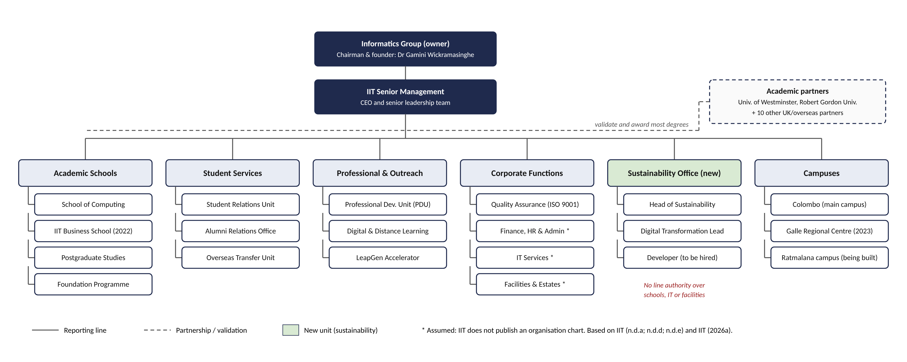
Figure 1: Organisational structure of IIT (2026)
Boxes marked * are assumed, because IIT does not publish an organisation chart.

References
IIT (2026a) 6BUIS019C Digital Strategy: Assessment Specification 2026/27. Colombo: Informatics Institute of Technology / University of Westminster.
IIT (2026b) IIT to host the 3rd International Conference on Sustainable Education 2026 (ICSE 2026) in Colombo. Available at: https://www.iit.ac.lk/iit-events/iit-to-host-the-3rd-international-conference-on-sustainable-education-2026-icse-2026-in-colombo/ (Accessed: 21 October 2026).
IIT (2026c) IIT launches its own UGC-approved BBA and Sri Lanka's first British FinTech degree. 30 September. Available at: https://www.iit.ac.lk/iit-news/iit-launches-its-own-ugc-approved-bba-and-sri-lankas-first-british-fintech-degree/ (Accessed: 22 October 2026).
IIT (n.d.a) About IIT. Available at: https://www.iit.ac.lk/about/ (Accessed: 22 October 2026).
IIT (n.d.b) SDGP: Software Development for Global Progress. Available at: https://sdgp.iit.ac.lk/ (Accessed: 21 October 2026).
IIT (n.d.c) LeapGen IIT Accelerator. Available at: https://leapgen.iit.ac.lk/ (Accessed: 21 October 2026).
IIT (n.d.d) Informatics Group. Available at: https://www.iit.ac.lk/about/informatics-group/ (Accessed: 22 October 2026).
IIT (n.d.e) Digital and Distance Learning (DDL). Available at: https://www.iit.ac.lk/study/ddl/ (Accessed: 22 October 2026).
Johnson, G., Whittington, R., Regnér, P., Angwin, D. and Scholes, K. (2020) Exploring Strategy: Text and Cases. 12th edn. Harlow: Pearson.
Mintzberg, H. (1979) The Structuring of Organizations. Englewood Cliffs, NJ: Prentice-Hall.
Waterman, R.H., Peters, T.J. and Phillips, J.R. (1980) 'Structure is not organization', Business Horizons, 23(3), pp. 14-26.

